

LAB EXPERIMENT RECORD

SET 29

Department | Artificial Intelligence and Data Science
Course Code / Course Name | DSA0601 / Data Handling and Visualization
Name / Register Number | ROHAN P T / 192424112
Date / Day | 22/10/2026

Aim
To analyze student academic performance using the requested visualizations and dashboard views.

Dataset
Student Academic Performance
Student_ID | Age | Study_Hours | Attendance | Test_Score | Participation_Score | Attendance_Quartile
S1 | 19 | 12 | 90 | 85 | 8 | Q4
S2 | 21 | 8 | 70 | 70 | 7 | Q2
S3 | 20 | 15 | 95 | 92 | 9 | Q4
S4 | 22 | 10 | 85 | 80 | 8 | Q3
S5 | 23 | 7 | 60 | 65 | 6 | Q1

R Data Setup
Run this setup once before the R programs below. The dataset is defined inline so each record can be copied and run without a separate CSV file.
R data setup
dat <- data.frame(
Student_ID = c("S1", "S2", "S3", "S4", "S5"),
Age = c(19, 21, 20, 22, 23),
Study_Hours = c(12, 8, 15, 10, 7),
Attendance = c(90, 70, 95, 85, 60),
Test_Score = c(85, 70, 92, 80, 65),
Participation_Score = c(8, 7, 9, 8, 6),
Attendance_Quartile = c("Q4", "Q2", "Q4", "Q3", "Q1")
)

PROGRAM 1: Student Test and Participation Area Chart
Create a stacked area chart of Test_Score and Participation_Score across students; analyze the pattern.
R code
library(ggplot2)
long <- reshape(dat, varying=c("Test_Score","Participation_Score"), v.names="Score", timevar="Measure", times=c("Test_Score","Participation_Score"), direction="long")
ggplot(long, aes(Student_ID, Score, fill=Measure)) + geom_area() + labs(title="Scores Across Students", x="Student", y="Stacked score values") + theme_minimal()

Data note: Test and participation scores use different scales; the stacked total is not a common performance measure.
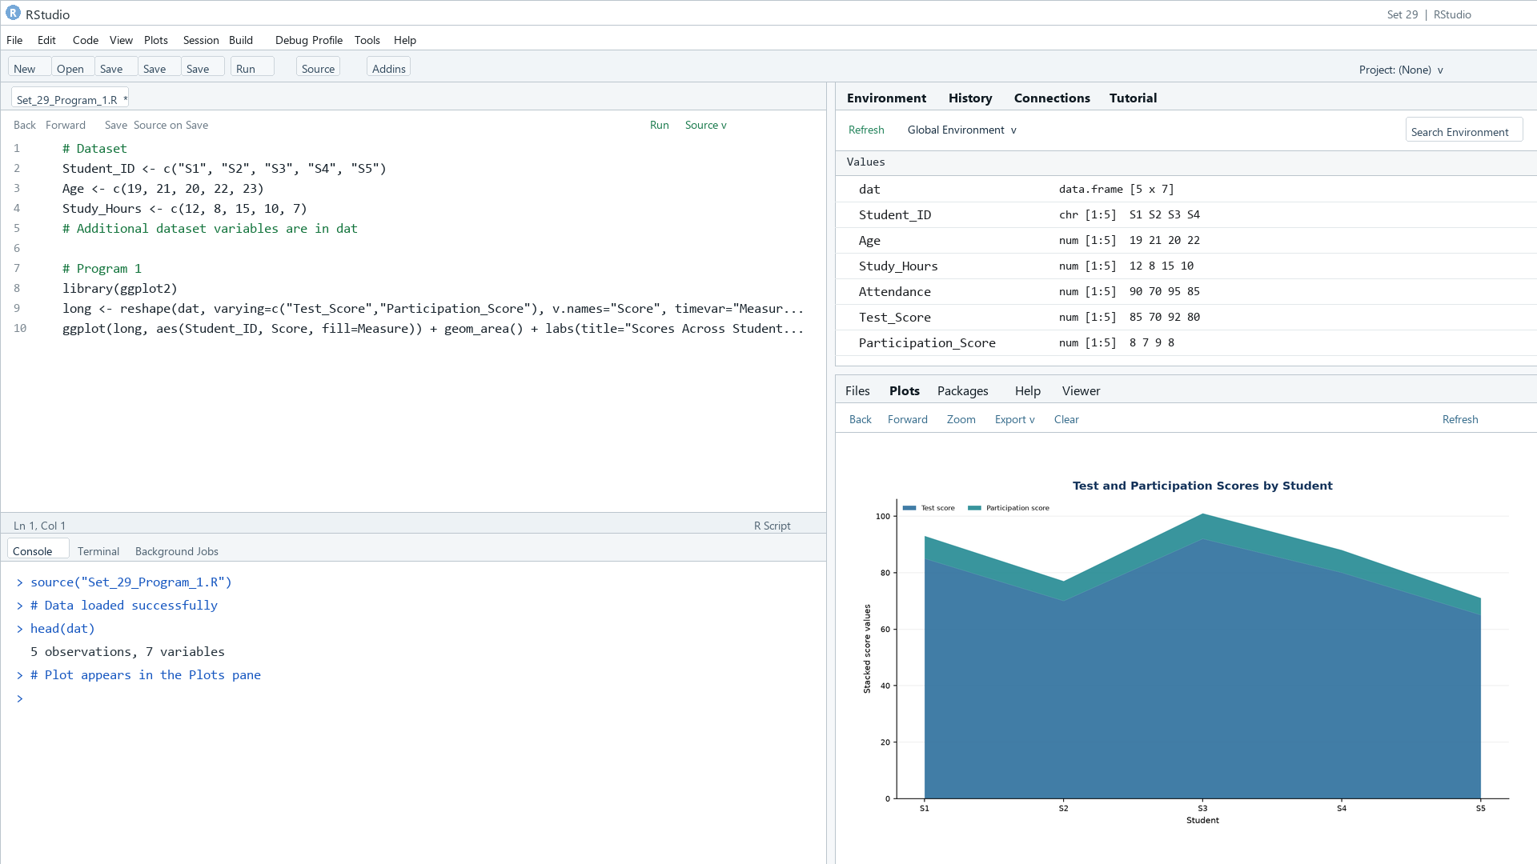
Output 1: Student Test and Participation Area Chart
Observation: Test scores vary from 65 to 92, while participation scores range from 6 to 9. The stacked values combine different scales, so the total area is descriptive only.

PROGRAM 2: Study Hours by Attendance Quartile
Create a colored boxplot of Study_Hours grouped by Attendance quartiles and interpret medians, spread, and outliers.
R code
boxplot(Study_Hours ~ Attendance_Quartile, data=dat, col=rainbow(4), xlab="Attendance quartile", ylab="Study hours", main="Study Hours by Attendance Quartile")

Data note: Quartile groups are ranked from the five supplied attendance values; the small groups make boxplot summaries unstable.
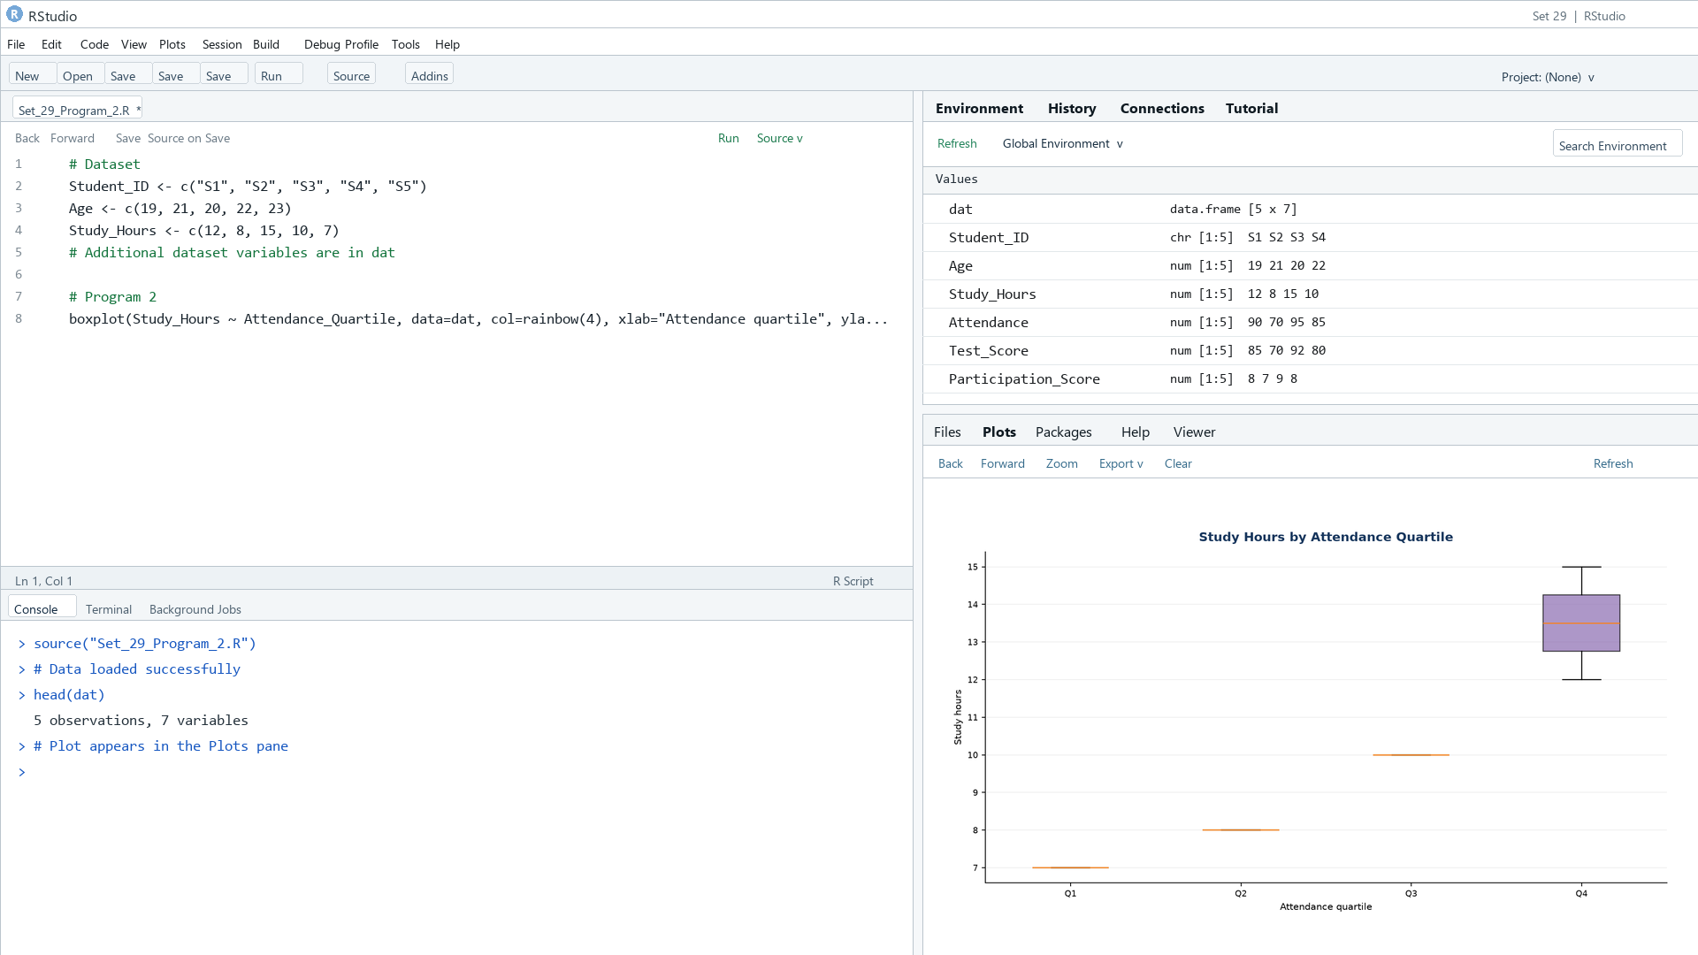
Output 2: Study Hours by Attendance Quartile
Observation: Median study hours rise from Q1 (7) through Q4 (13.5). Groups contain only one or two students, so quartile spreads and outliers cannot be estimated reliably.

PROGRAM 3: Test Score Density Plot
Create a density plot of Test_Score and evaluate the distribution and possible outliers.
R code
plot(density(dat$Test_Score), main="Density of Test Scores", xlab="Test_Score", col="#276B9A", lwd=2)

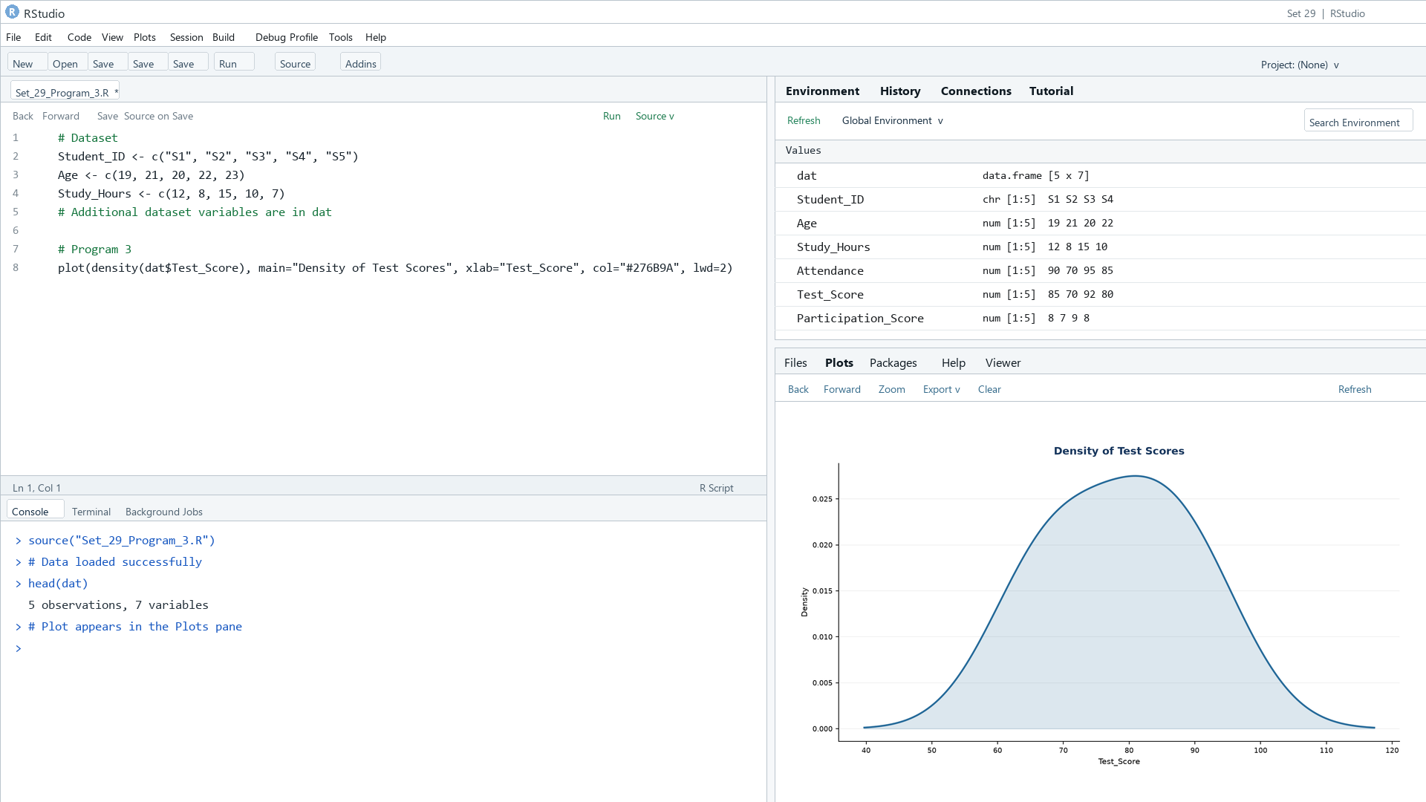
Output 3: Test Score Density Plot
Observation: The five scores span 65 to 92 with no isolated value apparent, but a five-point sample is too small for a reliable density or outlier assessment.

PROGRAM 4: Student Academic Performance Dashboard
Create an interactive Tableau scatter plot with Study_Hours on x, Test_Score on y, color by Participation_Score, and an Age filter.
Tableau build steps
Tableau dashboard build
1. Connect to the student academic performance table.
2. Create a scatter plot with Study_Hours on Columns and Test_Score on Rows.
3. Color marks by Participation_Score and include Student_ID in the tooltip.
4. Add Age as a filter and place the scatter plot on a dashboard.

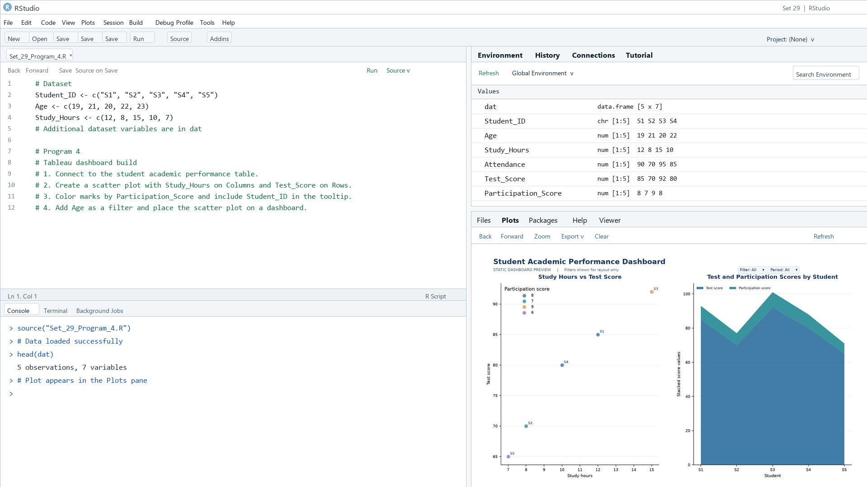
Output 4: Student Academic Performance Dashboard
Observation: The preview relates study hours to test scores and shows the score profile. Age is specified as a Tableau filter.

Procedure
1. Review the dataset table and confirm any illustrative fields noted in the record.
2. Run the R setup block once, then run the requested program code.
3. Compare the output screenshot with the observation and replace illustrative values when actual data is available.
4. For Tableau tasks, connect to the displayed data and follow the dashboard build steps.

Result
The requested charts and dashboard views for Set 29 were prepared from the displayed dataset. Outputs include labels, short observations, and code or dashboard construction steps.

Key Functions Used
plot(), barplot(), hist(), boxplot(), table().

